OXYGEN PROBE SAFETY NET
Provided by South Monmouthshire NCN
Working together to improve the health and wellbeing of the South Monmouthshire community

Why have I been given an oxygen probe?
Your GP surgery have assessed you (this may be by phone, video consultation or face to face) as having symptoms of covid-19. They are happy that you can safely self-manage your condition at home without needing to go to hospital as long as your condition remains the same. However they want to monitor your oxygen levels to check that they do not decrease to 95% or below over the next week which could indicate that your condition might be worsening.
When do I check my oxygen levels?
Please check your oxygen levels four time a day for the next week. Please also check your oxygen levels if you are feeling fatigued, more short of breath or if you feel hot or like you may have a temperature. To assist you please find a sheet that you can complete your readings. Please take these levels whilst sitting down and after a 40-step walk or if not practical a one-minute sit-to-stand.

Ring 999 if:

Your oxygen levels are 92% or below or your heart rate is over or
• You are unable to complete short sentences at rest due to breathlessness.
• Your breathing suddenly worsens within an hour.
OR if these more general signs of serious illness develop
• αρε coughing up blood
• have blue lips or a blue face
• feel cold and sweaty with pale or blotchy skin
• have a rash that does not fade when you roll a glass over it
• collapse or faint

Ring your GP/NHS 111 as soon as possible if:

If your oxygen levels are between 93% and 95%
• You slowly start feeling more unwell or more breathless for two or more hours.
• You are having difficulty breathing when getting up to go to the toilet or similar.
• You sense that something is wrong (general weakness, extreme tiredness,
loss of appetite, reduced urine output, unable to care for yourself – simple tasks
like washing and dressing or making food).

Your reading diary
Day | Reading stationary/after walking | Reading stationary/  after walking | Reading stationary/after walking | Reading stationary/after walking
1
2
3
4
5
6
7

Please contact your GP surgery if you are having any difficulty using the oxygen probe or if you are unsure of the instructions or readings.

How do I return my oxygen probe?
Please return your oxygen probe after one week of taking readings to your GP Practice
Please call your practice first to arrange the drop off
Please note it is vital to our fight against covid that you do return your probe in a timely manner so that other patients who are in need of this potentially important safety net have access to it.

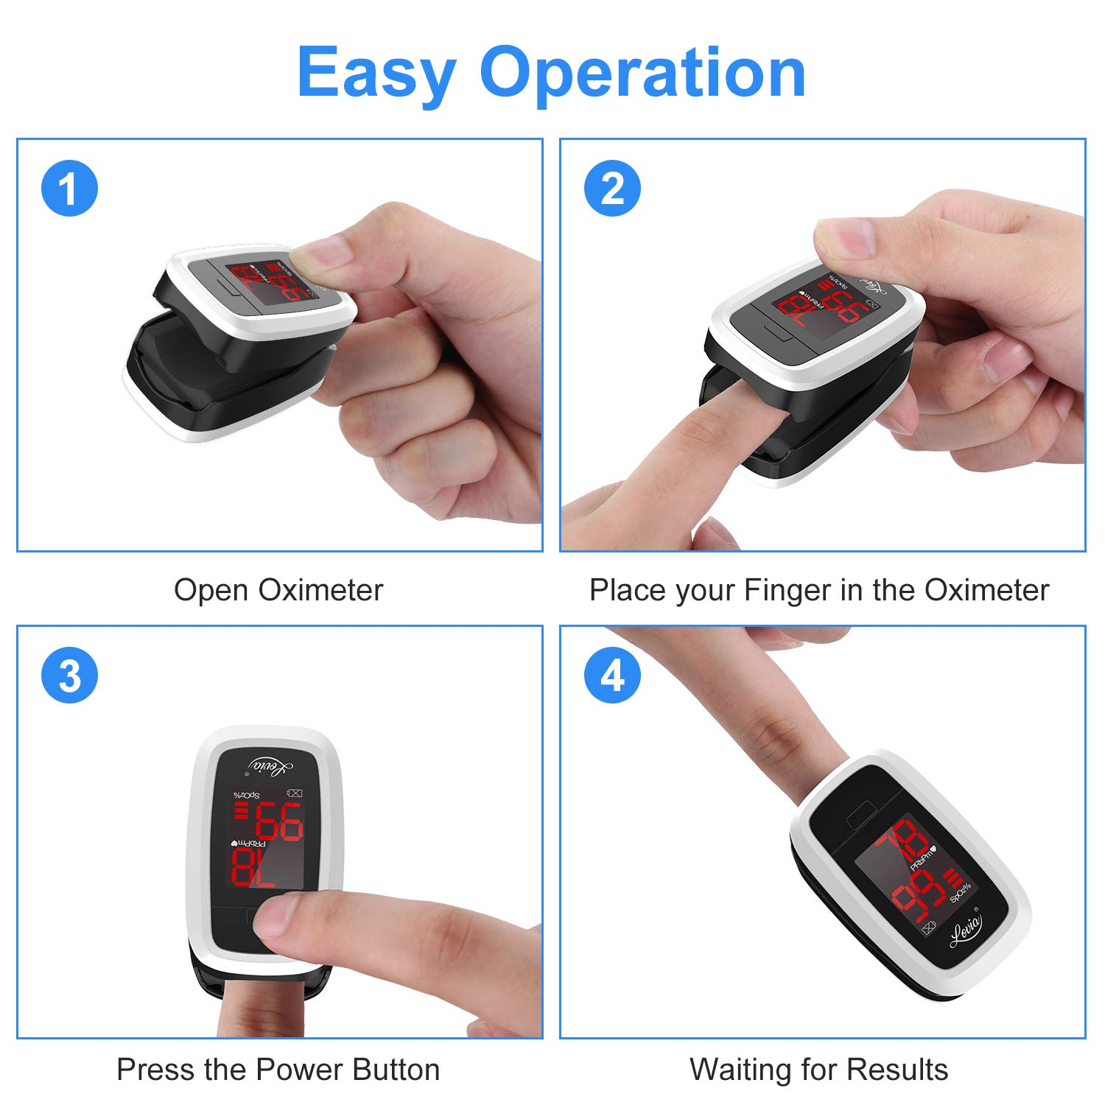
INSTRUCTIONS FOR USE
1. Wash and dry hands thoroughly.

2. Wrap index finger in single layer of cling film (if available).

3. Insert into Oximeter (as shown in picture overleaf) with nail uppermost.

4. Follow Easy Operation instructions attached.

5. Record PRbpm and Sp02% readings as shown on display.

6. Take 40 steps on the flat within the home, take and record second reading.

